State of California • Natural Resources Agency Gavin Newsom, Governor
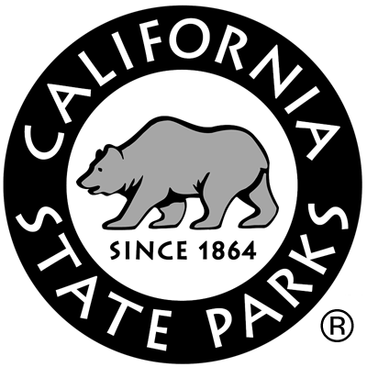
DEPARTMENT OF PARKS AND RECREATION Lisa Ann L. Mangat, Director

Anza-Borrego Desert State Park
200 Palm Canyon Drive
Borrego Springs, CA 92004
760 767-4037 Fax 760 767-3427

April 17, 2019

CALLING ALL SHEEP COUNTERS:

We hope you’re able to join us for the 49th Annual Bighorn Sheep Count at Anza-Borrego Desert State Park! And if you know of anyone who might be interested in participating please forward them this email. Any and all inquiries can be sent to AB.Sheepcount@parks.ca.gov.

The orientation, mandatory for all first-time counters and highly recommended for veterans, will be conducted at the University of California, Irvine Steele/Burnand Anza-Borrego Desert Research Center (located at 401 Tilting T Drive, Borrego Springs, CA, 92004) on Saturday, June 22th from 9AM-2PM. We know many of you have counted bighorn for years, but we can all use a refresher. The orientation will cover bighorn sheep identification, California Fish and Wildlife’s recovery efforts, bighorn sheep natural history, census methods, desert safety, and site assignments.

We will be dispersing to count sites on Thursday afternoon, July 4th, and conducting the count on Friday, July 5th, Saturday July 6th, and Sunday, July 7th. On Thursday, we will meet at the Palm Canyon Maintenance Shop between 1-3PM for check in and dispersal. We will expect you back at the shop by 3PM on Sunday to compile count data and get you headed home.

Please use the RSVP form on Page 2 to let us know if you’ll be able to help this year. As always, we need willing backpackers, and we need four wheel-drive vehicles to help get volunteers into some of the count sites.

Sheep population numbers in the Park are estimated at about 500, and totals for the entire Peninsular Ranges are almost 900 sheep.

We hope you can help us again this year and we thank you for your interest and dedication!

Sincerely,

Michael J. Puzzo
Sheep Count Coordinator
Anza-Borrego Desert State Park

2019 Sheep Count RSVP Form
*RSVP with this form by Monday, June 17, 2019*

Email to: AB.Sheepcount@parks.ca.gov

Mail to: Anza-Borrego Desert State Park
Attn: Sheep Count
200 Palm Canyon Dr
Borrego Springs, CA 92004

Fax to: (760) 767-3427

☐ I can be on the Sheep Count all three days- July 5 – July 7
☐ I will be at the Sheep Count Orientation on June 22 (Mandatory for first time counters)
☐ I have been on the Sheep Count in the past
☐ I have a 4WD and will help transport others
☐ I request the following partners: ,
☐ I request the following count sites: ,
☐ I will accept an assignment which requires backpacking. We need backpackers!
☐ I would like to reserve a campsite in Borrego Palm Canyon
To make a reservation at the Steele/Burnand Anza-Borrego Desert Research Center for the orientation and/or the sheep count, call 760-465-2656 or email Elaine at stulving@uci.edu with sheep count lodging in Subject line
Dorm Room: $20/night
Efficiency Room: $35/night ($45 for two people)
**Make checks payable to UC Regents and drop off/mail to:
SBABDRC – Elaine Tulving
PO Box 2098
401 Tilting T Dr.
Borrego Springs, CA 92004
Name
Email
Address
Cell Phone

In case of emergency during the sheep count, please notify:
Name:
Phone:

